**Milestone 1: Project Proposal**

**Design Overview:**

***Introduction:***

A wireless sensor node is capable of gathering information, processing that information, and communicating with other nodes in the same wireless network. In the case of this project, a solar panel, temperature sensor, bluetooth module, and a DC/DC converter all communicate to a computer or smartphone. The microcontroller that we will be using, powered by the solar panel, will gather temperature readings from the temperature sensor, process those readings, and display them onto a smartphone or computer.

The benefit of sensor nodes such as this one is the wireless communication component of it. A wireless sensor node allows for the transmitting side of the node to be in a completely different area than the receiving side, but still have the ability to communicate information efficiently. For this reason, wireless sensor nodes are ideal for applications such as solar powered fire detection systems that can detect forest fires, habitat monitoring, or even wearable healthcare monitoring devices.

Wireless sensor nodes are imperative to a plethora of industries to the wireless communication component. For example, the military often uses wireless sensor networks to detect enemy intrusion. The nodes allow for these industries to collect information remotely without having to be in the physical area of a hazard.

***Overview:***

The system starts with the “solar panel”, which is represented by the wall power supply and the Analog Discovery 2 (AD2). Through this solar panel, the DC/DC converter will be able to recharge the 9V battery that powers the Arduino microcontroller. The AD2 will also be utilized to conduct optimal load tests and supply waveforms to determine the system’s efficiency.

The DC/DC converter is connected to the output of the AD2. The AD2 provides five volts to the DC/DC converter. The DC/DC converter’s main function is to convert the 5V from the solar panel to a voltage that is suitable for charging the 9V battery. The converter is constructed using an inductor, a capacitor, a resistor and a switch. The capacitor and resistor form a filter that will remove any fluctuations in frequency from the “solar panel”. The inductor and switch form the basis of a Boost converter. The switch is controlled by a Pulse Width Modulation (PWM) signal that is sent by the Arduino.

The voltage output by the DC/DC converter is used to charge a 9 volt battery. This battery is connected to the Arduino, and it’s output voltage is used as both a power source and as a value to be analyzed by the system. In the code uploaded to the Arduino microcontroller, the voltage of the battery will be checked. If the battery is fully charged (i.e. the voltage is equal to or above the predetermined threshold), the code will process and display temperature readings every thirty seconds and then put the Arduino to sleep. Otherwise, the Arduino will continue to process and display temperature readings without going to sleep. Until the battery is fully charged again, the Arduino will modify the PWM signal to direct energy from the “solar panel” through the converter to recharge the battery. The PWM signal is directed through the digital pins of the Arduino, specifically one of the labeled tilde (~) pins.

In addition to the PWM signal, the digital pins of the Arduino also control the bluetooth components of the system. The bluetooth module will transmit the recorded temperature value to a computer or smartphone. The computer or smartphone will display the data. Connected to the Analog pins of the Arduino is the temperature sensor. The temperature sensor will read in the current temperature from its surrounding environment and transmit the value as a voltage to the Arduino analog pins. The pins will direct this value to the analog to digital converter and this value to the microcontroller where it will be processed, and eventually sent to the computer/smartphone display. These are some of the peripherals that are utilized from the Arduino system.

The Arduino peripherals that are utilized within this project are as follows: bluetooth library and controller, temperature sensor, clock for PWM, the monitor/display and related graphics information, and the input voltage from the DC/DC converter as both a power source and a value to analyze for the PWM system.

***Block Diagram:***

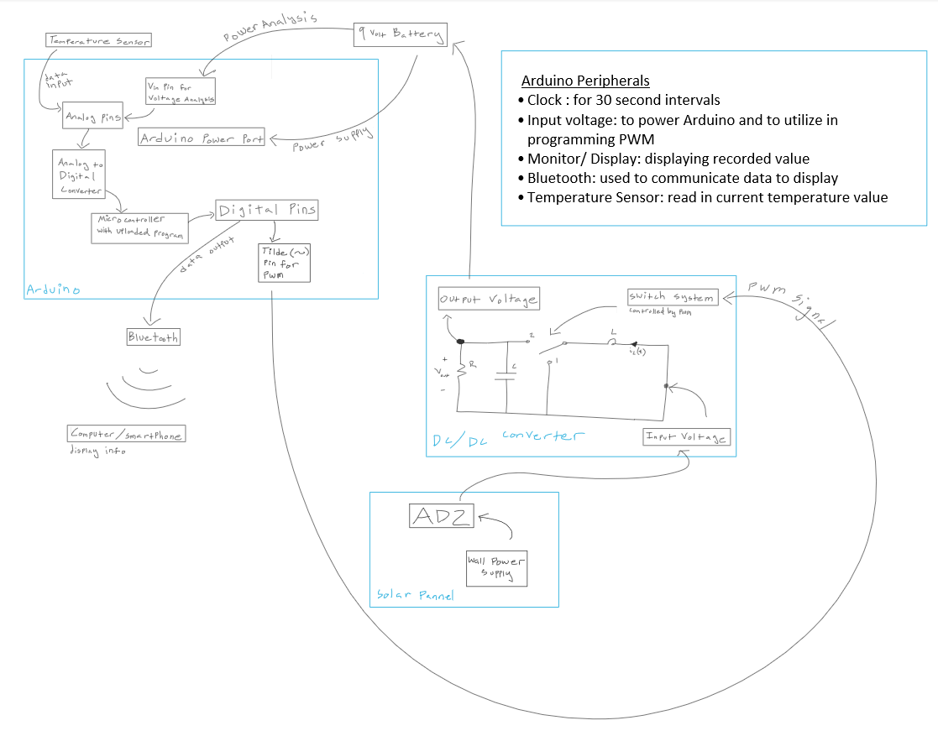

**Future Milestones:**

***Milestone 2:***

***Goals for hardware: Create a DC/DC converter that, under different input voltages, regulates the output at a constant voltage***

***Goals for software: At this milestone, we will focus mainly on hardware***

***Deliverables:***

***Deliverable 2: A working DC/DC converter without the PWM feedback control***

***Deliverable 3: Optimal load test***

***Testing outline: We will test the DC/DC converter using an optimal load test. The y-axis will be the efficiency and the y-axis will be the load resistance.***

***Milestone 3:***

***Goals for hardware: DC/DC converter should be able to recharge the 9V battery when the battery is less than fully charged. The DC/DC converter should also have PWM feedback control.***

***Goals for software: The Arduino should be able to communicate with the DC/DC converter through PWM, and the Arduino should operate based on the charge of the 9V battery.***

***Deliverables:***

***Deliverable 4: Show battery charging and discharging waveforms***

***Testing outline:***

***Checking the waveforms as well as if the Arduino is working properly to test out the charging and discharging of the battery***

***Milestone 4:***

***Goals for hardware: At this milestone, the hardware should be completely implemented.***

***Goals for software: By this milestone, the temperature sensor and bluetooth will be able to communicate with the Arduino and the Arduino will have code such that the temperature readings can be displayed on a smartphone.***

***Deliverables:***

***Deliverable 1: A working prototype that satisfies the requirements***

***Testing outline:***

***Incrementally testing the code and checking display on smartphone, optimal load test, and battery charging and discharging waveforms***

***Milestone 5:***

***Goals for hardware: The hardware should be completely implemented.***

***Goals for software: The software should be completely implemented.***

***Deliverables:***

***The final report and presentation which includes an introduction, high level diagram, detailed design of components, validation of overall project, and conclusion.***